South Vancouver Neighbourhood House (SVNH) Community Advisory Board Application

Thank you for your interest in joining the Community Advisory Board for South Vancouver Neighbourhood House (SVNH). Prior to applying, visit www.southvan.org
to learn more.

How to Apply
- Complete this application.
- Write a statement of interest (max. 500 words) about why you are interested in joining the SVNH Community Advisory Board (CAB) and what you hope to bring.
- Attach a resume, CV, or equivalent that captures your education and experience.
- Email these three (3) items to Mimi Rennie (Executive Director), at mimi.rennie@southvan.org. Deadline to apply is July 31st, 2026

APPLICATION

Personal Information

Name:

Address:

City: Province: Postal Code:

Phone: Email:

Demographics and Diversity
SVNH hopes to build a Community Advisory Board that reflects the diversity of and demographics within our community. With this goal in mind, please indicate which of the following groups you belong to, or have in-depth experience with/knowledge of:

- Newcomers, immigrants, refugees
- Youth (min. age of 16 for applicants)
- Seniors or elders (55+)
- Parents/guardians of youth/
young adults
- Individuals with disabilities
- Indigenous peoples
- 2SLGBTIA+ community
- Other _________________

Education, Skills and Experience
In addition to people with a connection to South Vancouver, SVNH also seeks individuals with a range of knowledge, experiences, and skills that are relevant to our work.

Which of the following areas do you have knowledge of, skills in, or experience with? (check all that apply):

- Board Governance
- Community Development
- Education
- Families, Children & Youth
- Financial Management/Accounting
- Government Relations
- Health or Public Health
- Indigenous Reconciliation
- Information Technology
- Legal Expertise
- Marketing and Communications
- Neighbourhood House Movement
- Settlement and Immigration
- Seniors
- Sustainability
- Other______________________

Interest in Board roles:
SVNHCommunity Advisory Board members may have the opportunity to take on additional roles, or serve on committees. Which opportunities might interest you?

- Chair (works closely with House ED)
- Vice-Chair (helps/stands in for Chair)
- Treasurer (shares finances with CAB)
- Secretary (notes and documents)

There is also an opportunity for a member of the Community Advisory Board to serve on the ANHBC Board. Would you be interested in this (now/in future)? ⃝ Yes ⃝ No.

Connection to South Vancouver
In brief, describe your connection to the community of South Vancouver (resident, work in area, etc.) What makes South Vancouver special? Refer to map below for a visual reference.
________________________________________________________________________________________________________________________________________________________________________________________________________________________________________________________________________________________________________________________________________________________________________________________________________________________________________________________________________________________________________________________________________________________________________________________
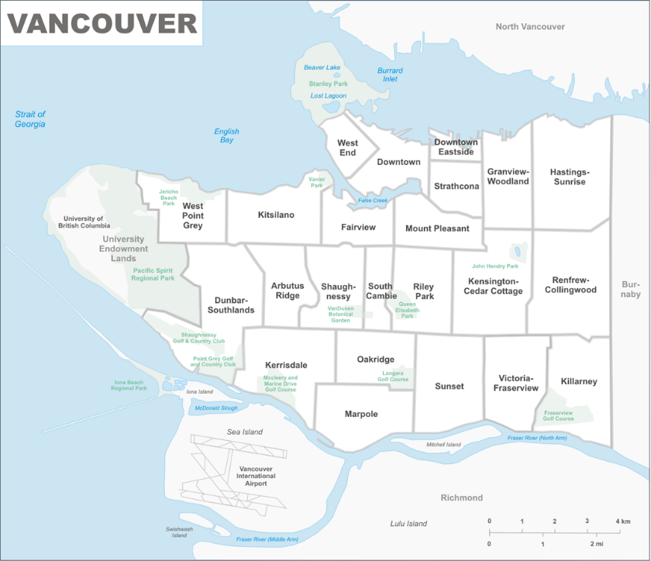

What is a Neighbourhood House?
Neighbourhood Houses operate on the belief that it is the neighbourhood that directly affects the lives of individuals and families. A neighbourhood house is a central hub for the community, connecting different kinds of services, helping neighbours of all ages and backgrounds connect, and providing a space where people are empowered to make change happen in their lives.

Role of the Community Advisory Board (CAB)
The Community Advisory Board is an advisory body that helps to identify needs, challenges, and opportunities within the community of South Vancouver. They help focus on the resources and programming of SVNH to better address the community they serve.

SVNH is a part of the Association of Neighbourhood Houses of BC (ANHBC). The ANHBC Board provides oversight and governance over all houses and camps.

Commitment and responsibility
SVNH CAB members are expected to serve a full two-year term* and to:
- Prepare for and attend Board meetings.
- Respond promptly to communications.
- Work respectfully and collaboratively with fellow CAB members and the ED.
- Participate in training, team-building, etc. as required.
*Youth representatives can choose to do a one-year term.

Benefits
As a member of our Community Advisory Board, you will have the opportunity to make meaningful difference in the community of South Vancouver. Other benefits include:
- Gaining experience in community leadership and working on a Board.
- Meeting and connecting with people from your community.
- Learning about neighbourhood houses and their role in healthy communities.
- Chance to learn from and work with a diverse group of people.

I understand the role of the CAB and the commitment required from me if selected.

Contact: If you require more info please contact Mimi Rennie, Executive Director.
Email: mimi.rennie@southvan.org Phone: 604-324-6212

